Chapter 10, Solution 70.

Using Fig. 10.113, design a problem to help other students to better understand op amps in AC circuits.

Although there are many ways to work this problem, this is an example based on the same kind of problem asked in the third edition.

Problem

The circuit in Fig. 10.113 is an integrator with a feedback resistor. Calculate v_{o}(t) if v_{s} = 2 cos 4 × 10⁴t V.

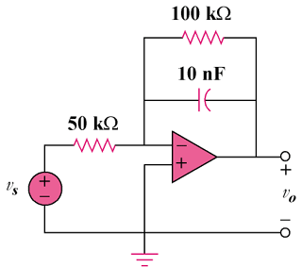

Figure 10.113

Solution

This may also be regarded as an inverting amplifier.
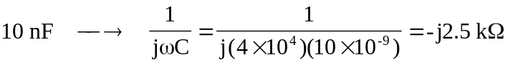

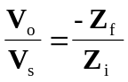
where 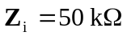 and 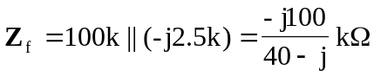.
Thus, 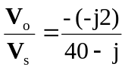

If 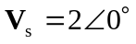,
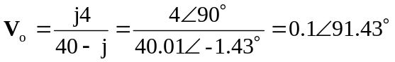

Therefore,
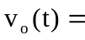 100 cos(4x10⁴ t + 91.43) mV

